FUNDRAISER APPLICATION & AGREEMENT

Organization Name: _______________________________________
Organization Address: ______________________________________
Organization Phone: _______________________________________
Organization Email: _______________________________________
Organization Website: _____________________________________
Organization Tax Identification Number: _______________________

Primary Contact: __________________________________________
Primary Contact Phone: ____________________________________
Primary Contact Email: _____________________________________

Proposed Date(s) for Fundraiser: _____________________________
May include up to 15 days, Monday through Thursday with a one month maximum between the proposed start and end dates.
Proposed Flyer for Fundraiser: Please attach

By signing this form, the above named organization:
- Certifies that it is a registered 501(c) non profit or a charitable school organization.
- Agrees to submit a sample flyer for prior approval to Pasta Bene with the understanding that Pasta Bene reserves sole discretion to approve the fundraiser and the flyer.
- Agrees to not distribute the flyer inside of Pasta Bene or close to Pasta Bene inside the red zone:
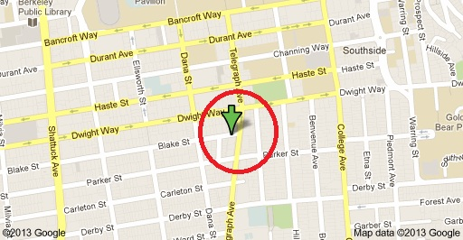
- Agrees to not distribute the flyer after the approved fundraising dates below or prior to receiving Pasta Bene’s approval as evidenced by its signature below or email confirmation.
- Agrees to the restrictions to be included on the flyer:
This coupon may not be combined with any special offers, discounts or promotions.
One flyer per diner or per multiple diners paying together required.
Catering excluded.
Authorized Signature: _______________________________
Print Name: ________________________________ Date: _________________
Pasta Bene Approval
Approved Dates: ___________________________________
Authorized Signature: _______________________________
Print Name: ________________________________ Date: _________________

